

Practical No.: 8
Aim –
To access and validate form fields using JavaScript events and design a Gym Admission Registration Form with live input validation.
Software/Tools Required –
- VSCode
- Chrome
- HTML5
- CSS3
- Javascript (ES6)
Experiment Program Code –
index.html
<!DOCTYPE html>
<html>
<head>
<title>Gym Admission Form</title>
<style>
*{
margin:0;
padding:0;
box-sizing:border-box;
}

body{
font-family:"Segoe UI", Arial, sans-serif;
min-height:100vh;
display:flex;
justify-content:center;
align-items:center;
padding:30px 15px;
background:
linear-gradient(rgba(104, 105, 106, 0.88),rgba(78, 120, 134, 0.92)),
url("https://images.unsplash.com/photo-1571902943202-507ec2618e8f?auto=format&fit=crop&w=1600&q=80");
background-size:cover;
background-position:center;
}

.container{
width:420px;
padding:30px 32px;
background:rgba(255,255,255,0.96);
border-radius:18px;
box-shadow:0 10px 30px rgba(60,90,100,0.18);
border:1px solid #e3eeee;
}

h2{
text-align:center;
color:#285b63;
font-size:26px;
margin-bottom:24px;
font-weight:700;
}

h2::after{
content:"";
display:block;
width:45px;
height:3px;
background:#55a6a6;
margin:8px auto 0;
border-radius:5px;
}

label{
display:block;
margin-top:14px;
margin-bottom:6px;
color:#18272b;
font-size:14px;
font-weight:600;
}

input,
select{
width:100%;
padding:11px 13px;
border:1px solid #ccdcdc;
border-radius:8px;
outline:none;
background:#f9fcfc;
color:#33484d;
font-size:14px;
transition:0.25s;
}

input:focus,
select:focus{
border-color:#65aeb0;
background:white;
box-shadow:0 0 0 3px rgba(101,174,176,0.12);
}

select option{
color:#333;
}

.error{
display:block;
color:#e05b5b;
font-size:12px;
margin-top:4px;
min-height:15px;
}

button{
width:100%;
padding:12px;
margin-top:20px;
background:#55a6a6;
color:white;
border:none;
border-radius:8px;
font-size:15px;
font-weight:600;
cursor:pointer;
transition:0.25s;
}

button:hover{
background:#438f90;
transform:translateY(-1px);
}

.success{
color:#31916d;
font-size:14px;
text-align:center;
font-weight:600;
margin-top:16px;
}

@media(max-width:500px){
.container{
width:100%;
padding:25px;
}

h2{
font-size:23px;
}
}
</style>
</head>
<body>

<div class="container">
<h2>GYM ADMISSION FORM</h2>

<form id="gymForm">

<label>Full Name</label>
<input type="text" id="name">
<span id="nameError" class="error"></span>

<label>Age</label>
<input type="number" id="age">
<span id="ageError" class="error"></span>

<label>Email</label>
<input type="email" id="email">
<span id="emailError" class="error"></span>

<label>Mobile Number</label>
<input type="text" id="mobile">
<span id="mobileError" class="error"></span>

<label>Membership Plan</label>
<select id="plan">
<option value="">Select Plan</option>
<option>Monthly</option>
<option>Quarterly</option>
<option>Yearly</option>
</select>
<span id="planError" class="error"></span>

<button type="submit">Submit</button>

<p id="result" class="success"></p>

</form>
</div>

<script>

document.getElementById("name").addEventListener("input", function(){
let name=this.value;
if(/^[A-Za-z ]+$/.test(name)){
document.getElementById("nameError").innerHTML="";
}else{
document.getElementById("nameError").innerHTML="Only letters allowed.";
}
});

document.getElementById("age").addEventListener("blur", function(){
let age=this.value;
if(age>=16 && age<=60){
document.getElementById("ageError").innerHTML="";
}else{
document.getElementById("ageError").innerHTML="Age must be between 16 and 60.";
}
});

document.getElementById("email").addEventListener("input", function(){
let email=this.value;
let pattern=/^[^\s@]+@[^\s@]+\.[^\s@]+$/;

if(pattern.test(email)){
document.getElementById("emailError").innerHTML="";
}else{
document.getElementById("emailError").innerHTML="Invalid email.";
}
});

document.getElementById("mobile").addEventListener("input", function(){
let mobile=this.value;

if(/^\d{10}$/.test(mobile)){
document.getElementById("mobileError").innerHTML="";
}else{
document.getElementById("mobileError").innerHTML="Enter 10-digit mobile number.";
}
});

document.getElementById("plan").addEventListener("change", function(){
if(this.value==""){
document.getElementById("planError").innerHTML="Please select a plan.";
}else{
document.getElementById("planError").innerHTML="";
}
});

document.getElementById("gymForm").addEventListener("submit", function(e){

e.preventDefault();

if(
document.getElementById("nameError").innerHTML=="" &&
document.getElementById("ageError").innerHTML=="" &&
document.getElementById("emailError").innerHTML=="" &&
document.getElementById("mobileError").innerHTML=="" &&
document.getElementById("plan").value!=""
){
document.getElementById("result").innerHTML="Gym Admission Successful!";
}
else{
document.getElementById("result").innerHTML="";
alert("Please correct the errors before submitting.");
}
});

</script>

</body>
</html>
Output –
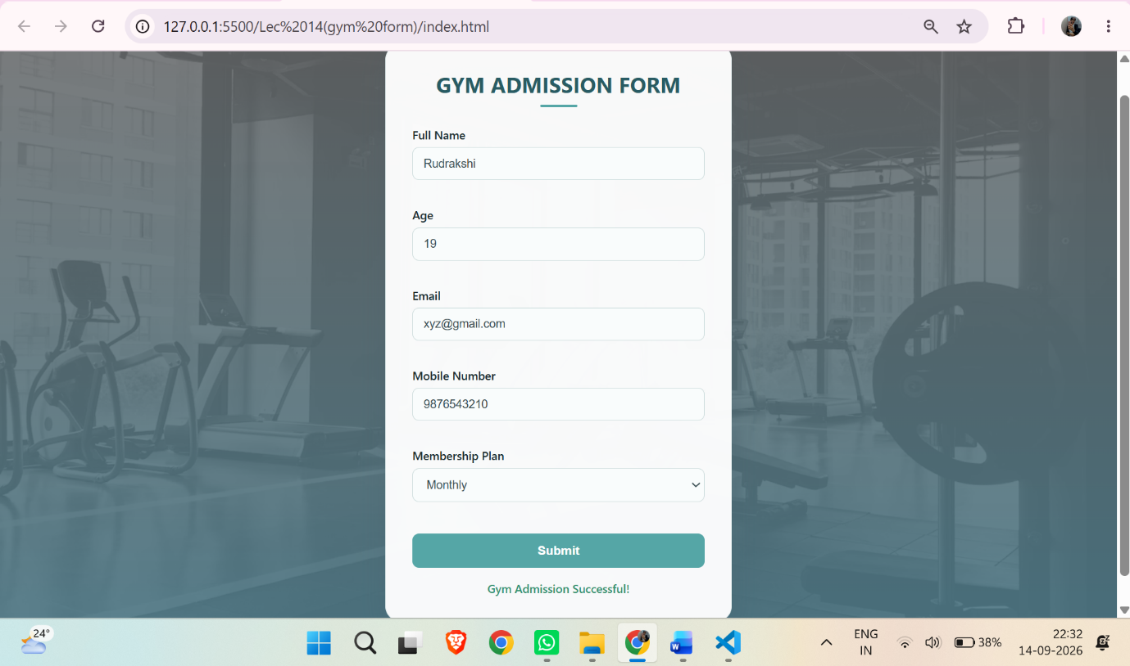
Case Study Title –
Gym Admission Registration Form Design a Gym Admission Registration Form using HTML, CSS and JavaScript. The form should collect basic information from a person who wants to register for gym admission. The form should contain:
Case Study Program Code –

index.html
<!DOCTYPE html>
<html lang="en">
<head>
<meta charset="UTF-8">
<meta name="viewport" content="width=device-width, initial-scale=1.0">
<title>Gym Admission Form</title>
<link rel="stylesheet" href="style.css">
</head>
<body>

<div class="form-container">

<h2>Gym Admission Form</h2>
<p class="subtitle">Registration Form</p>

<form id="gymForm">

<table>

<tr>
<th>Name</th>
<th>Value</th>
</tr>

<tr>
<td>Name</td>
<td>
<input type="text" id="name">
<span id="nameError"></span>
</td>
</tr>

<tr>
<td>Sex</td>
<td>
<label>
<input type="radio" name="sex" value="Male">
Male
</label>

<label>
<input type="radio" name="sex" value="Female">
Female
</label>

<span id="sexError"></span>
</td>
</tr>

<tr>
<td>Eye color</td>
<td>
<select id="eyeColor">
<option value="">Select</option>
<option value="Green">Green</option>
<option value="Blue">Blue</option>
<option value="Brown">Brown</option>
<option value="Black">Black</option>
</select>

<span id="eyeError"></span>
</td>
</tr>

<tr>
<td>Check all that apply</td>
<td>
<label>
<input type="checkbox" name="fitness" value="Over 6 feet tall">
Over 6 feet tall
</label>

<label>
<input type="checkbox" name="fitness" value="Over 200 pounds">
Over 200 pounds
</label>
</td>
</tr>

<tr>
<td colspan="2" class="description">
Describe your athletic ability:
</td>
</tr>

<tr>
<td colspan="2" class="textarea-cell">
<textarea id="ability"></textarea>
<span id="abilityError"></span>
</td>
</tr>

<tr>
<td colspan="2" class="button-cell">
<button type="submit">Enter my information</button>
</td>
</tr>

</table>

</form>

<div id="result"></div>

<footer>
Designed By: <span>Rudrakshi Bhandekar</span> |
PRN: <span>24070521012</span>
</footer>

</div>

<script src="script.js"></script>

</body>
</html>

Style.css
* {
margin: 0;
padding: 0;
box-sizing: border-box;
}

body {
min-height: 100vh;
display: flex;
justify-content: center;
align-items: center;
padding: 35px 20px;
font-family: "Segoe UI", Arial, sans-serif;
background:
radial-gradient(circle at 10% 15%, #b9d9ff 0, transparent 28%),
radial-gradient(circle at 90% 85%, #f4c4e1 0, transparent 28%),
linear-gradient(135deg, #e8f3ff, #f9eff8);
color: #30394d;
}

.form-container {
width: 600px;
max-width: 100%;
padding: 32px;
background: rgba(255, 255, 255, 0.95);
border: 1px solid #ffffff;
border-radius: 20px;
box-shadow: 0 20px 50px rgba(71, 82, 130, 0.2);
}

/* Heading */

h2 {
text-align: center;
font-size: 29px;
font-weight: 750;
color: #4c55a5;
letter-spacing: 0.4px;
margin-bottom: 5px;
}

.subtitle {
text-align: center;
color: #b04d87;
font-size: 11px;
font-weight: 600;
letter-spacing: 2.5px;
text-transform: uppercase;
margin-bottom: 24px;
}

/* Table */

table {
width: 100%;
border-collapse: separate;
border-spacing: 0;
overflow: hidden;
border: 1px solid #d3d9e8;
border-radius: 12px;
background: white;
}

th {
padding: 11px;
background: linear-gradient(135deg, #5968c7, #8467c9);
color: white;
font-size: 13px;
letter-spacing: 0.8px;
text-align: center;
}

td {
border-top: 1px solid #e3e6ef;
padding: 10px 12px;
font-size: 13px;
vertical-align: middle;
}

td:first-child {
width: 38%;
background: #f3f5ff;
color: #505a72;
font-weight: 600;
}

td:last-child {
background: #ffffff;
}

/* Inputs */

input[type="text"],
select {
width: 100%;
height: 35px;
padding: 7px 11px;
border: 1px solid #ccd2df;
border-radius: 7px;
outline: none;
background: #fafbff;
color: #343c4f;
font-size: 12px;
transition: 0.25s;
}

input[type="text"]:hover,
select:hover,
textarea:hover {
border-color: #8995ca;
}

input[type="text"]:focus,
select:focus,
textarea:focus {
border-color: #6675ca;
background: white;
box-shadow: 0 0 0 4px rgba(102, 117, 202, 0.12);
}

/* Radio and Checkbox */

label {
display: inline-flex;
align-items: center;
gap: 5px;
margin: 3px 14px 3px 0;
color: #4d566a;
font-size: 12px;
cursor: pointer;
}

label:hover {
color: #5968bd;
}

input[type="radio"],
input[type="checkbox"] {
width: 15px;
height: 15px;
accent-color: #6976c8;
cursor: pointer;
}

/* Description */

.description {
background: linear-gradient(135deg, #f3f5ff, #faf2f8) !important;
color: #505a72;
font-weight: 600;
}

/* Textarea */

.textarea-cell {
padding: 11px;
}

textarea {
width: 100%;
height: 115px;
resize: vertical;
padding: 10px;
border: 1px solid #ccd2df;
border-radius: 8px;
outline: none;
background: #fafbff;
color: #343c4f;
font-family: "Segoe UI", Arial, sans-serif;
font-size: 12px;
transition: 0.25s;
}

/* Error */

span {
display: block;
min-height: 14px;
margin-top: 4px;
color: #d34f6a;
font-size: 10px;
}

/* Validation */

.valid {
border-color: #48a878 !important;
background: #f5fff9 !important;
}

.invalid {
border-color: #e05c70 !important;
background: #fff7f8 !important;
}

/* Button */

.button-cell {
padding: 16px;
text-align: center;
background: #f5f6fb !important;
}

button {
padding: 10px 28px;
border: none;
border-radius: 8px;
background: linear-gradient(135deg, #5968c7, #8a61c9);
color: white;
font-size: 12px;
font-weight: 650;
letter-spacing: 0.3px;
cursor: pointer;
box-shadow: 0 8px 18px rgba(93, 102, 190, 0.3);
transition: 0.25s;
}

button:hover {
transform: translateY(-2px);
background: linear-gradient(135deg, #4d5dbd, #7c55bd);
box-shadow: 0 12px 23px rgba(93, 102, 190, 0.38);
}

button:active {
transform: translateY(0);
}

/* Result */

#result {
display: none;
margin-top: 17px;
padding: 14px 16px;
border-radius: 9px;
background: linear-gradient(135deg, #f0f3ff, #fff1f8);
border: 1px solid #dce0ee;
border-left: 4px solid #6976c8;
color: #46516a;
font-size: 12px;
line-height: 1.8;
}

#result.show {
display: block;
}

/* Footer */

footer {
margin-top: 18px;
text-align: center;
color: #2d354a;
font-size: 16px;
font-weight: 500;
}

footer span {
display: inline;
color: #293983;
font-weight: 650;
font-size: 16px;
}

/* Mobile */

@media (max-width: 600px) {
body {
padding: 20px 10px;
}

.form-container {
padding: 22px 15px;
border-radius: 16px;
}

h2 {
font-size: 24px;
}

th,
td {
padding: 8px;
font-size: 11px;
}

label {
font-size: 11px;
margin-right: 7px;
}
}

Script.js
const form = document.getElementById("gymForm");
const name = document.getElementById("name");
const eyeColor = document.getElementById("eyeColor");
const ability = document.getElementById("ability");
const result = document.getElementById("result");

function validateName() {
if (name.value.trim() === "") {
document.getElementById("nameError").textContent =
"Name is required";
name.classList.add("invalid");
return false;
}

if (!/^[A-Za-z ]+$/.test(name.value.trim())) {
document.getElementById("nameError").textContent =
"Use alphabets only";
name.classList.add("invalid");
return false;
}

document.getElementById("nameError").textContent = "";
name.classList.remove("invalid");
name.classList.add("valid");
return true;
}

function validateSex() {
const sex = document.querySelector('input[name="sex"]:checked');

if (!sex) {
document.getElementById("sexError").textContent =
"Please select sex";
return false;
}

document.getElementById("sexError").textContent = "";
return true;
}

function validateEyeColor() {
if (eyeColor.value === "") {
document.getElementById("eyeError").textContent =
"Please select eye color";
eyeColor.classList.add("invalid");
return false;
}

document.getElementById("eyeError").textContent = "";
eyeColor.classList.remove("invalid");
eyeColor.classList.add("valid");
return true;
}

function validateAbility() {
if (ability.value.trim() === "") {
document.getElementById("abilityError").textContent =
"Please describe your athletic ability";
ability.classList.add("invalid");
return false;
}

document.getElementById("abilityError").textContent = "";
ability.classList.remove("invalid");
ability.classList.add("valid");
return true;
}

name.addEventListener("input", validateName);
eyeColor.addEventListener("change", validateEyeColor);
ability.addEventListener("input", validateAbility);

document.querySelectorAll('input[name="sex"]').forEach(function(radio) {
radio.addEventListener("change", validateSex);
});

form.addEventListener("submit", function(event) {

event.preventDefault();

const validName = validateName();
const validSex = validateSex();
const validEye = validateEyeColor();
const validAbility = validateAbility();

if (validName && validSex && validEye && validAbility) {

const sex = document.querySelector(
'input[name="sex"]:checked'
).value;

const fitness = [];

document.querySelectorAll(
'input[name="fitness"]:checked'
).forEach(function(item) {
fitness.push(item.value);
});

result.innerHTML =
"<b>Registration Successful!</b><br>" +
"Name: " + name.value + "<br>" +
"Sex: " + sex + "<br>" +
"Eye Color: " + eyeColor.value + "<br>" +
"Fitness Details: " +
(fitness.length ? fitness.join(", ") : "None");

result.classList.add("show");

alert("Gym Admission Form Submitted Successfully!");
} else {
result.classList.remove("show");
alert("Please fill the form correctly.");
}
});
Output –
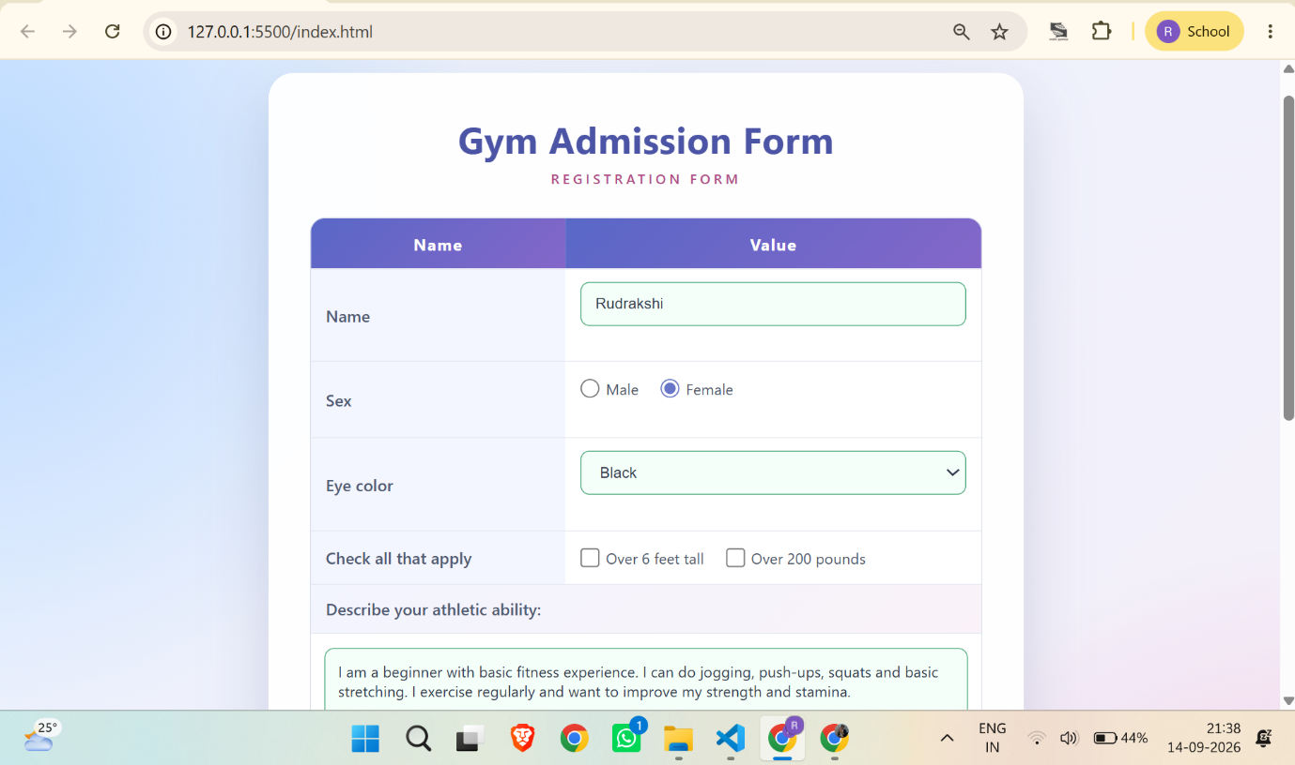
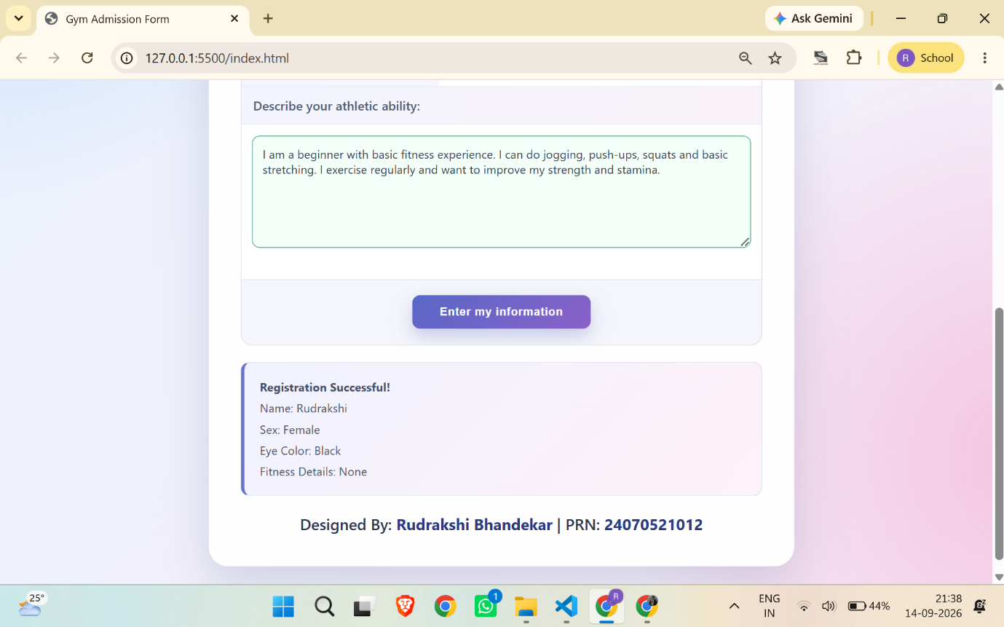

Conclusion –
In this experiment, a Gym Admission Registration Form was designed using HTML, CSS and JavaScript. Form fields were accessed and manipulated using the DOM. JavaScript events such as input, change, focus, blur and submit were used to perform live form validation. Invalid inputs were identified and appropriate messages were displayed to the user. The experiment demonstrated the practical use of JavaScript events and form validation for creating interactive web forms.

